Home Work:

How to Create an ER Diagram in SQL Developer

Contents

1. Open SQL Developer 2

2. Open the Data Modeler Browser 2

3. Input the Information from the Data Dictionary 2

4. Choose the mybooks schema 3

5. Choose the mybooks Schema 3

6. Choose the Tables to Import 3

7. Click Finish 4

8. Click Close 4

9. Save Model 5

10. Arrange the Model into this pattern 5

11. Save Model 6

# Open SQL Developer

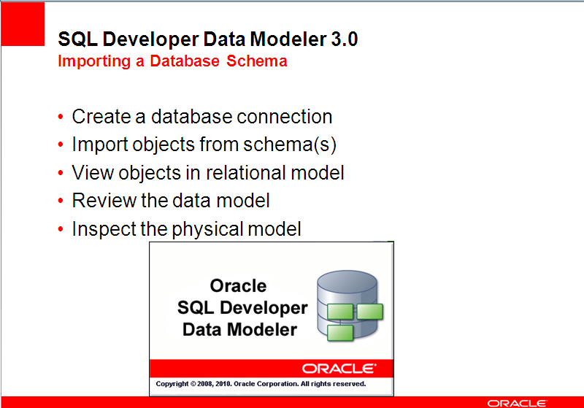

# Open the Data Modeler Browser

Select View > Data Modeler > Browser

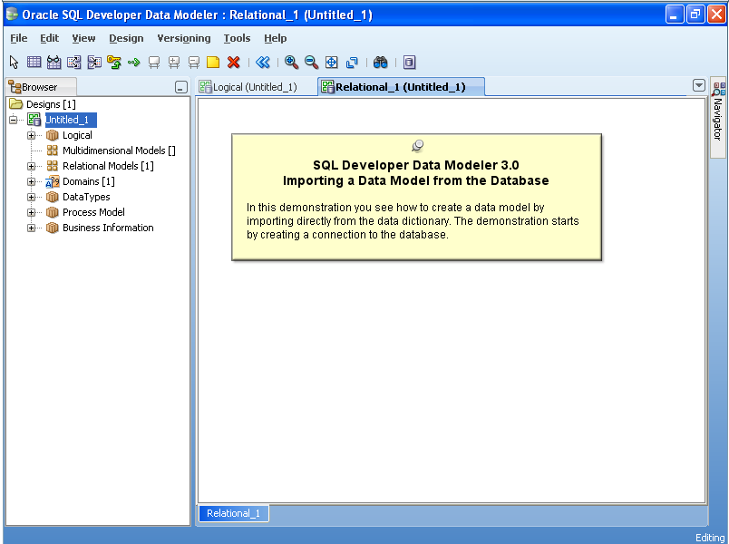

# Input the Information from the Data Dictionary

Select File > Data Modeler > Import > Data Dictionary

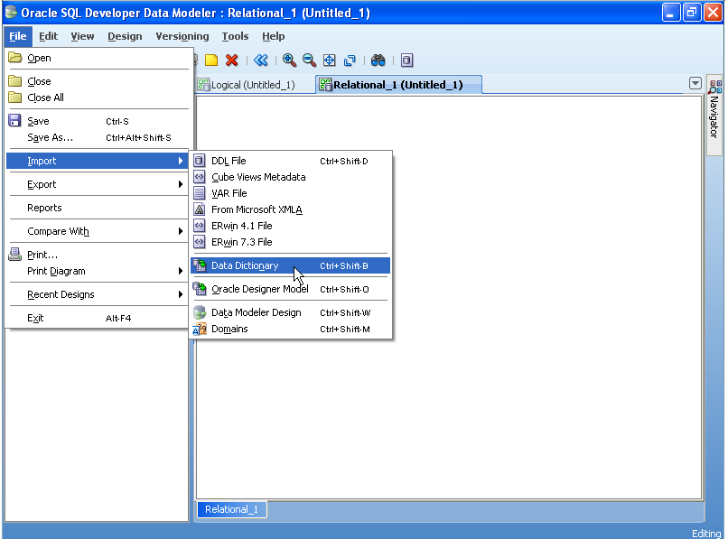

# Choose the mybooks schema

Double Click the mybooks Schema at the top of the window

When the Next button at the bottom becomes enabled click Next

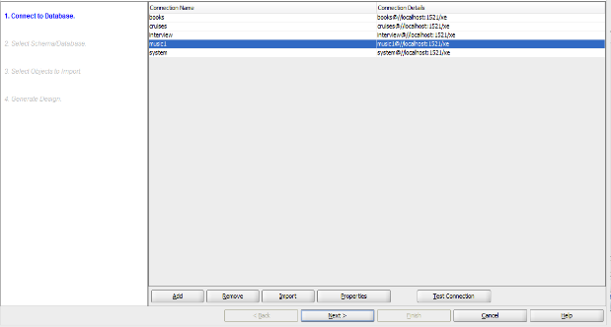

# Choose the mybooks Schema

Select the mybooks Schema

When the Next button at the bottom becomes enabled click Next

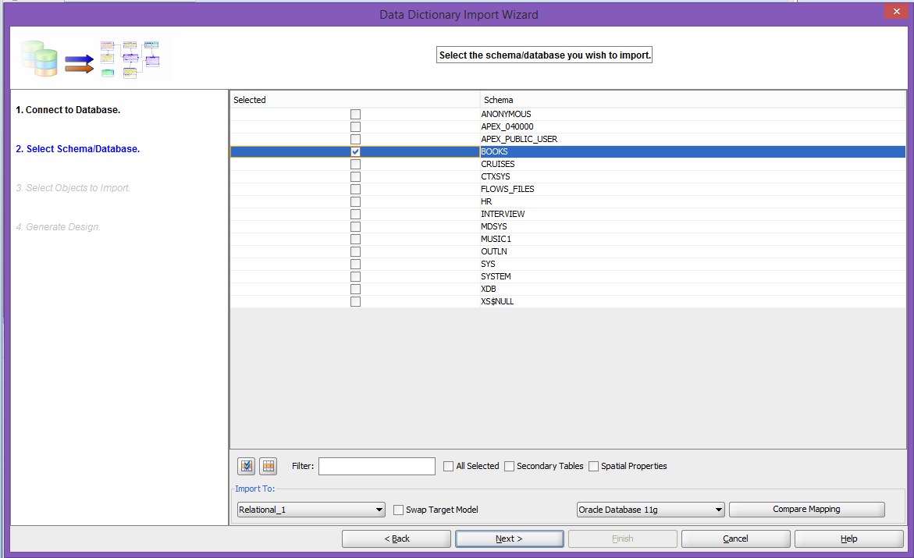

# Choose the Tables to Import

Place a check mark next to the following tables: Customers, Orders, OrderItems, Books, BookAuthor, Author, Publisher, Promotion.

When the Next button at the bottom becomes enabled click Next

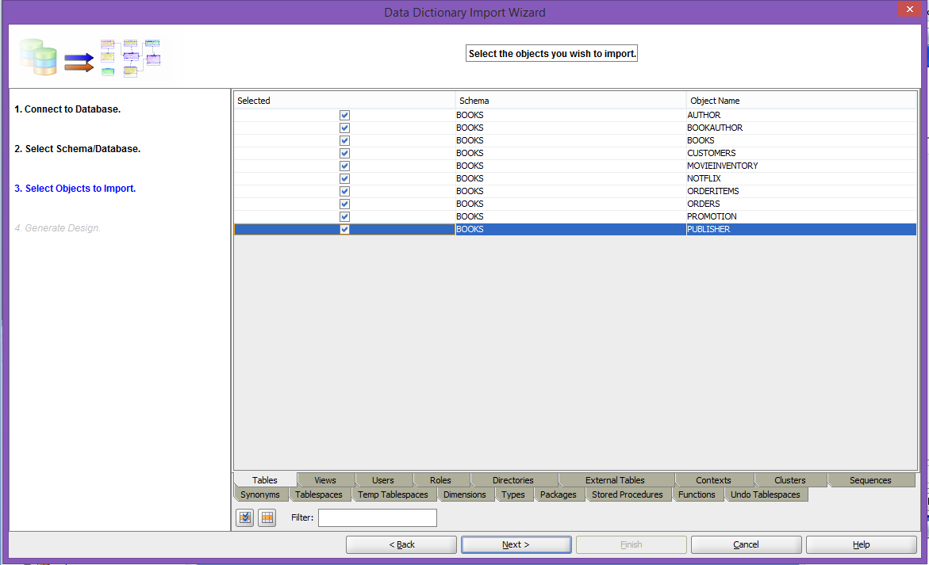

# Click Finish

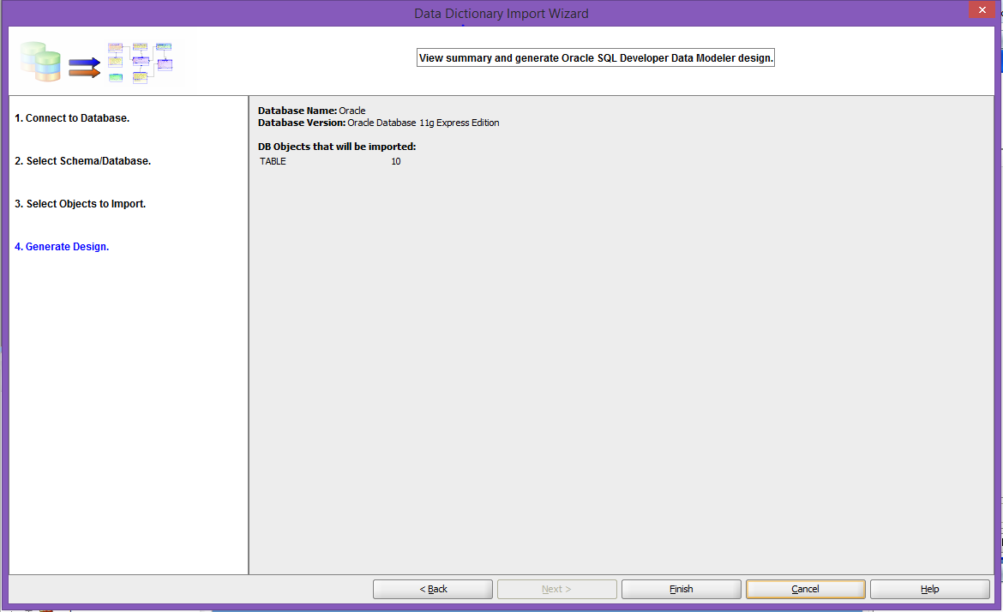

# Click Close

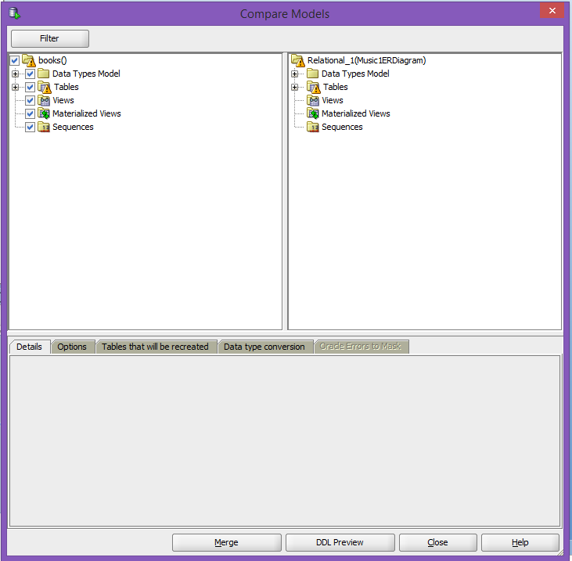

# Save Model

Select File > Data Modeler > Save As (type in a name) and click save.

# Arrange the Model into this pattern

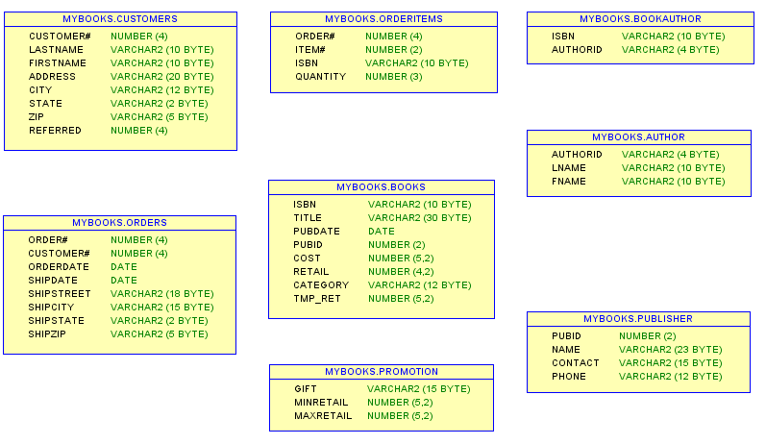

# Save Model

Select File > Data Modeler > Save As **myBooksERDiagram** and click save.

# Alter this schema

Add primary keys, foreign keys, and whatever other constraints you like.

# add primary keys

# foreign keys

# And whatever other constraints you like

# Refresh model

Double Click the Relational_1 (myBooksERDigram) tab

Select the Customers table (you will now see 8 blue squares around it)

Click > Ctrl-A (you will now see all tables with 8 blue squares around each)

Right-Click > Customers > Synchronize With Data Dictionary

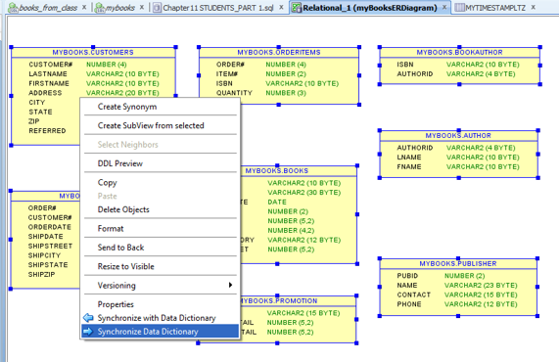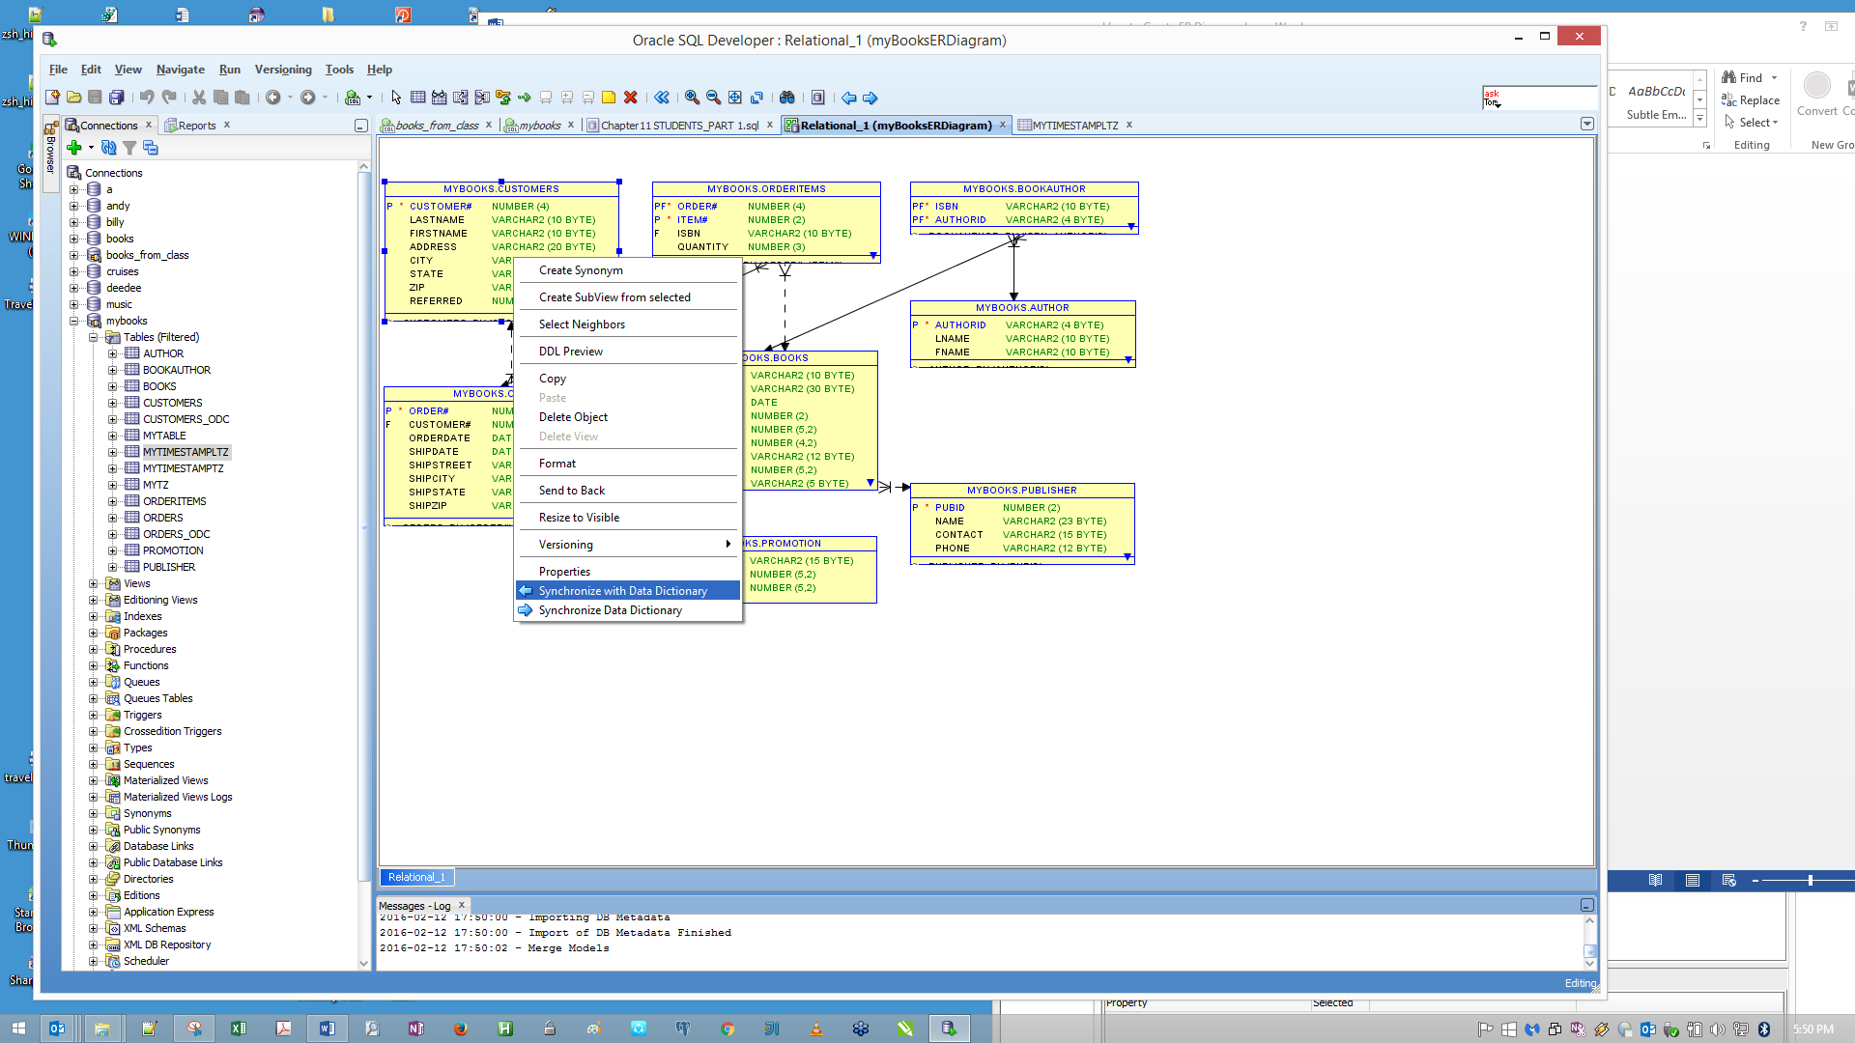

Click > Merge

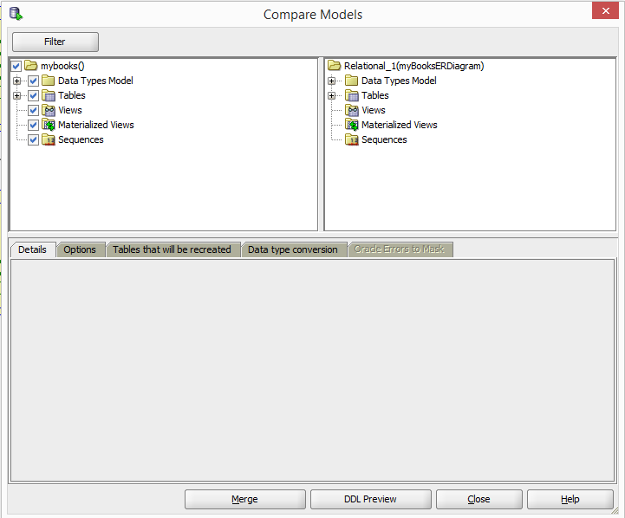

# Touch Up Model

Right Click on Dotted line > Properties > Mandatory

Select handle and pull to resize tables

Select File > Data Modeler > Save

